Simeon Patton

In-class activity Week 7

CS362 OSU Spring 2021

*All Code can be found at: <https://github.com/pattons-OSU/CS362_InClassActivities/tree/master/Week_7>

*To run pytest programs: in a powershell window type “pytest (program title)

Program 1;

*Create program that takes in user input and checks to see if input is a palindrome. Create Unittest and Pytest programs and catalog output here.*

Program Code: palindrome.py

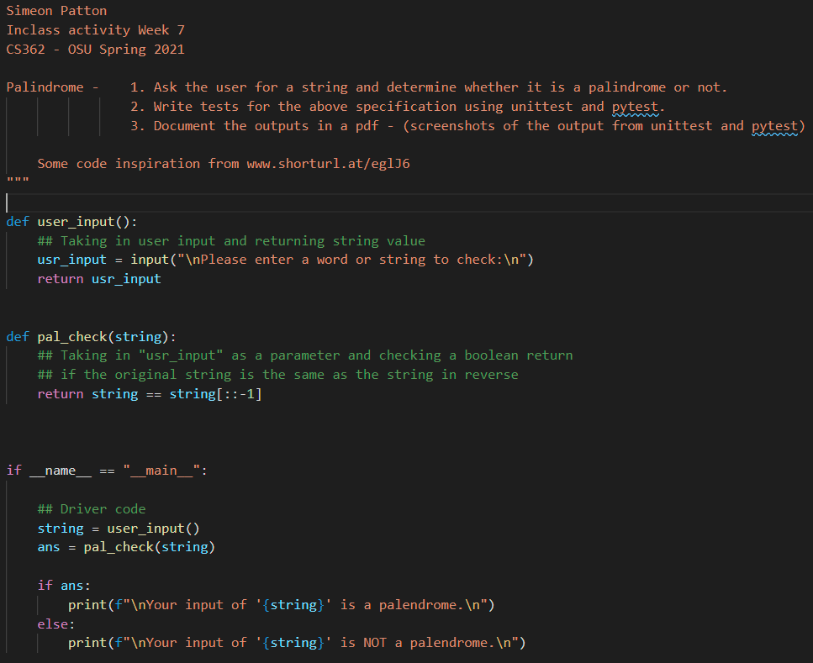

Unit-test Code: test_palindrome.py

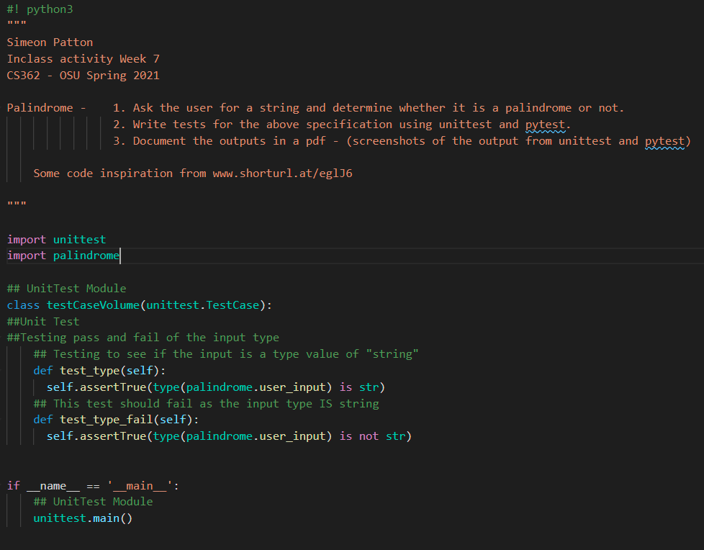

Unit-test powershell output:

One of the tests is designed to fail and one to pass. This was checking to make sure that the user input is indeed a data type of string.

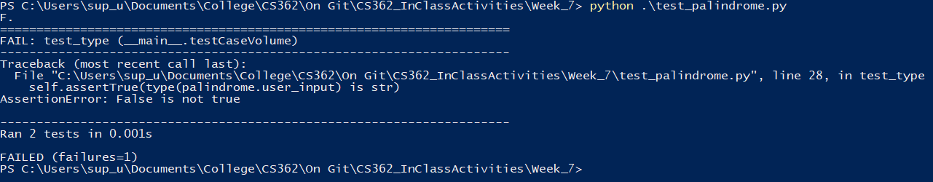

Pytest Code: pytest_palindrome.py

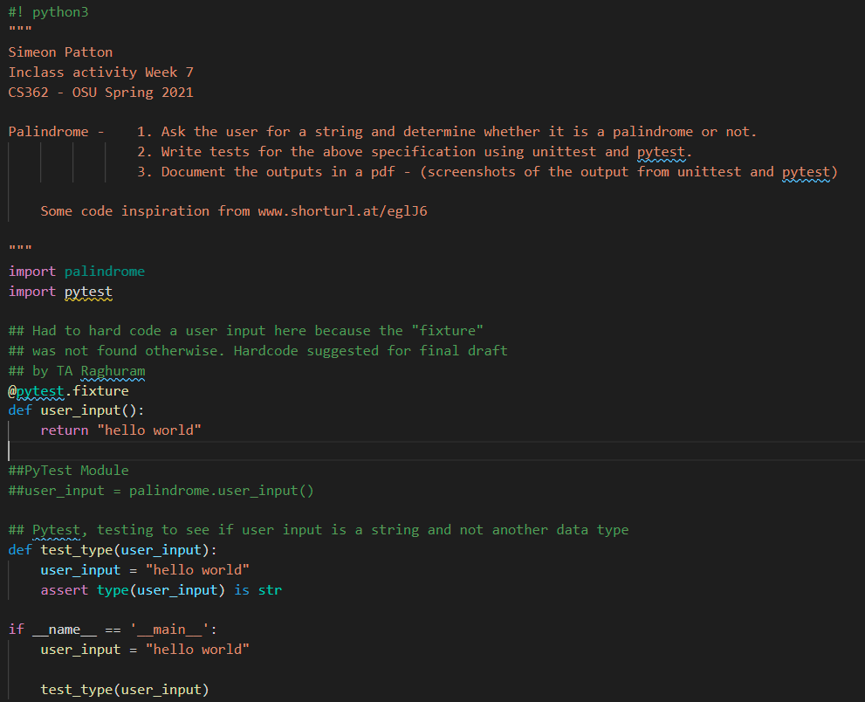

Pytest powershell output: Run command “pytest ./pytest_palindrome.py”

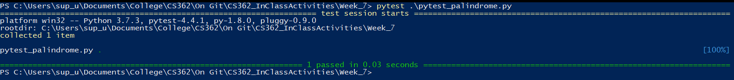

Program 2;

*Create program that takes in user input and counts the number of words found within the input string. Create Unittest and Pytest programs and catalog output here.*

Program Code: word_count.py

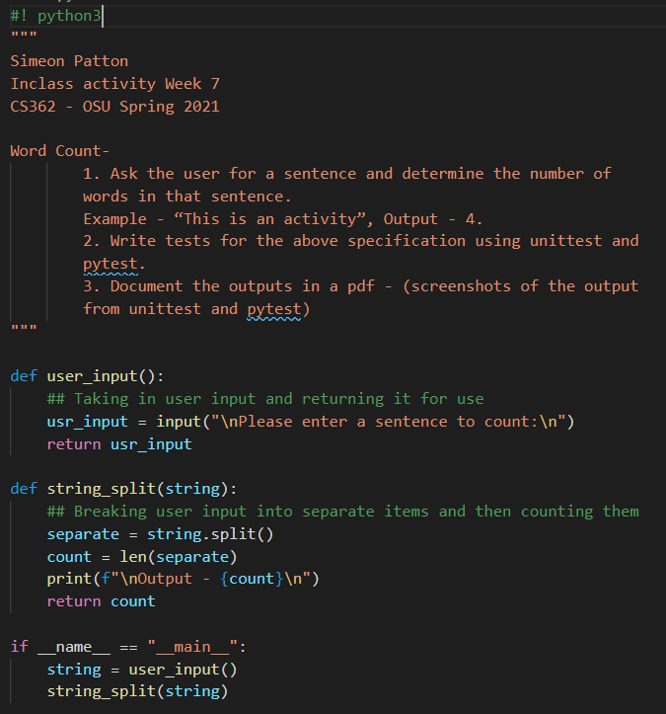

Unit-test code: test_word_count.py